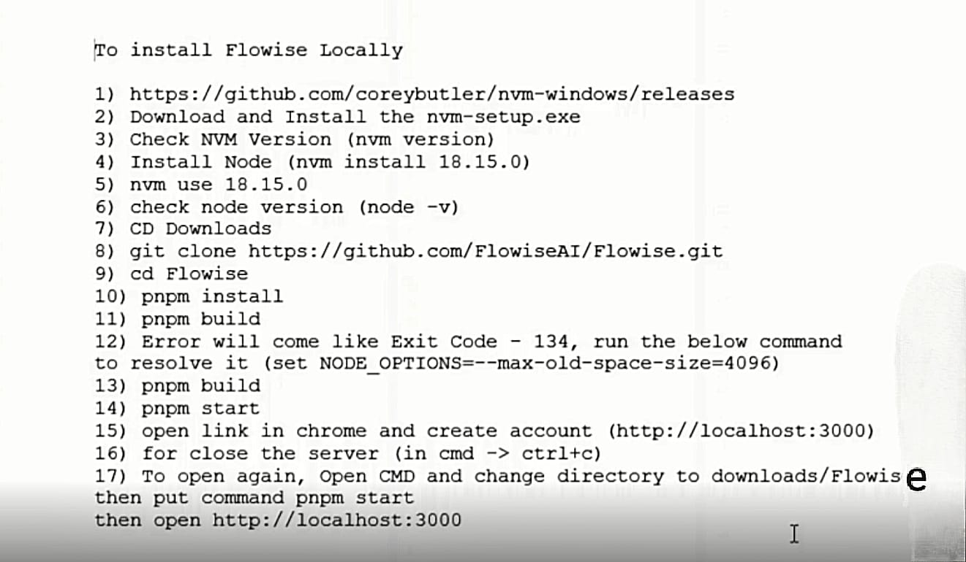

**Flowise Environmental Variables**

FLOWISE_USERNAME

FLOWISE_PASSWORD

NODE_VERSION - 20.18.1

DATABASE_PATH - /opt/render/.flowise

APIKEY_PATH - /opt/render/.flowise

LOG_PATH - /opt/render/.flowise/logs

SECRETKEY_PATH - /opt/render/.flowise

Note: Blue will work only in paid STARTER plan – for free plan BLUE font items not required